Compliments, Comments & Complaints Policy.
 | It is important for us to hear what you think about Orchardville – good and bad.  You could tell us about compliments, comments or complaints
 | A compliment could be saying thank you to someone who helped you.
 | A compliment could be saying well done to someone for doing a good job.
 | A comment could be telling us about an idea you have had to make things better at Orchardville.
 | To tell us about your compliments, comments or complaints you can send us an email.  You should send your email to  talktous@orchardville.com
   | If you prefer to write to us you can post a letter to –  Louise Macrory  Quality & Compliance Manager  Orchardville  144 – 152 Ravenhill Road  Belfast, BT6 8ED.  Or you can hand deliver your letter to any Orchardville office.  You must make sure your letter is sealed and clearly addressed.
 | You can also call, text or WhatsApp Louise on 07860 952 559.

 | If you are unhappy with Orchardville for any reason you can complain.  The rest of this easy read document explains what will happen if you complain to Orchardville.
 | Complaining is telling us about something that has made you unhappy or upset.  It is important you tell us so that we can fix the problem and stop it from happening again.
   | For example you might complain if  - Orchardville staff have treated you badly.  - You don’t feel safe at Orchardville.  - you feel ignored or not listened to.  These are just examples but you can tell us about anything at Orchardville which makes you unhappy or upset.

 | Sometimes making a complaint can be difficult. You could ask someone you trust to support you.  You are welcome to bring a supporter to any meetings you have with us.
 | The Patient Client Council can also help support you to make a complaint.  Freephone: 0800 917 0222  Email: complaints.pcc@hscni.net
 | Louise Macrory will investigate any complaints made at Orchardville. (Contact details on Page2)
 | Once Louise gets your complaint she will contact you within 5 days to let you know what will happen next.  Occasionally this might take slightly longer if she’s on holidays for example.
 | Louise will make an appointment to meet with you to talk about your complaint.
 | Louise will take notes on what you say.
 | Some complaints are easy to fix and we will solve them together without taking any other action.  Some complaints are more difficult and we may need to investigate.
 | Louise will investigate your complaint if this is necessary.  Investigate means we’ll ask questions and find out more about what happened. We will interview anyone who is involved.
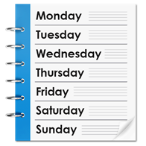   | After an investigation is complete, Louise will contact you to tell you what she found out and what action we will take, if any.  She will contact you within 2 weeks of your meeting.
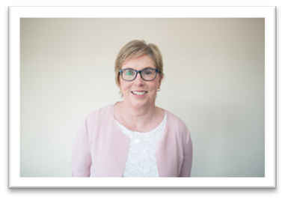 | If you’re not happy with how Louise deals with your complaint or you’re not happy with her decision, contact Joan McGinn.  Joan McGinn is Orchardville's Chief Executive.
You can write to Joan at:
Orchardville,144 – 152 Ravenhill Road, Belfast, BT6 8ED.

 | After Joan has reviewed your complaint, she will arrange a meeting to discuss it with you.  At the meeting Joan will tell you what she has decided to do about your complaint.
Joan will confirm her decision and the reasons for her decision in writing within two weeks of your meeting.

This is Orchardville’s final decision.

 | If you are still unhappy the Public Services Ombudsman is an independent organisation who can help you if you think your complaint has not been fairly treated.  Freephone: 0800 343424  Email: nipso@nipso.org.uk

